Quantum GIS Basic Operations (Lisboa 1.8)
Vector Operations
The QGIS Manual steps through many more basic operations than the following exercise, and will be occasionally be referenced within these NOTE boxes. See the full manual here (updated regularly): http://docs.qgis.org/html/en/user_manual/
- Prepping Excel sheet for QGIS
Unlike ArcMap, which can work directly with data from an Excel spreadsheet, QGIS recognizes .csv and .txt files. Coordinates, however, should still be recorded in decimal degrees.
- There should be no blank cells in the latitude or longitude columns.
NOTE: To use an Excel file with QGIS, you will need to open an ODBC connection with the Database Connection Module, which is covered in detail in the QGIS Manual 1.7.0 Sect 12.5.3.

- Adding XY Coordinates from a .csv file
- Look for the “Add Delimited Text Layer” icon in top row of icons. 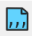
- Click the “Browse” button to and select the .csv file with your coordinates to add.
  - After selecting your file, the dialog for “Layer Name” should automatically be filled. You may rename this layer if you choose.
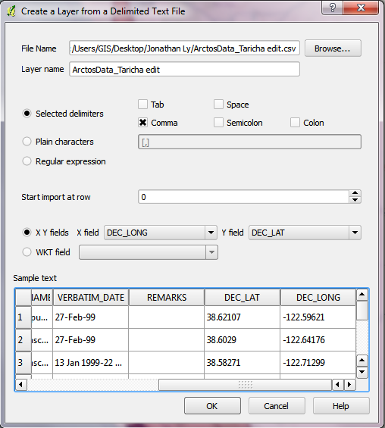
- The option “Selected delimiters” affects how QGIS separates and reads the data in the cells. For the .csv format, check the box for “Comma”
(If you’ve changed the extension of an Excel spreadsheet to .csv in order to make in work with QGIS, you may have to check the box for “Tab”.)

- QGIS will try to guess which columns of data to use when it assigns an X and Y field.
The X and Y fields represent your longitude and latitude respectively.

- Click “OK” to bring up the menu “Coordinate Reference System Selector”. On this window, click WGS84.
- The points should now be displayed in the Data View. For now, the scale bar will be in degrees, but the addition of a basemap will set the scale bar to a unit of length.
- Right click on the projected XY points in the “Layers” window and select the option “Save as…”.
  - Under the option “Format”, select ESRI Shapefile.
  - Name the file in the box “Save as”
  - Click on “Browse” to choose where you want to save the file.
  - Click “OK” to save the file.

- Checking the coordinate reference system of a layer
  - Before moving on, it might be helpful to make a note of what Coordinate Reference System (CRS) a particular layer is in.
  - To do this, you can simply right-click on the layer in the “Layers” window and select “Properties”.
  - In the menu that opens, click on the tab “Metadata”. The CRS is recorded in the field “Layer Spatial Reference System”.
    - In this example, the shapefile is recorded as:
“+proj=longlat +datum=WGS84 +no_defs”

- Reprojecting the coordinate reference system of a shapefile
- Creating a new shapefile
- Right-click the layer of the shapefile of the data points in the “Layers” window and click “Save as…”
- Click “Browse” and choose where you want to save the file, then click “Save”.
- Look for the second drop-down menu under “Encoding” and select the option “Selected CRS”.
- After selecting “Selected CRS”, you will be able to choose a new CRS by clicking on the “Browse” button next to the field. Doing so will bring up a dialog that allows you to choose a new CRS more relevant to your data points.
  - In this example, I selected “NAD27 / California Albers” since many of my coordinates plot to California.
- Once you’ve selected your new CRS, you can click “OK” to create a new shapefile. You can then unmark the box of the original shapefile since we will no longer be using it.
- Using the reprojected shapefile
- Click on “Layer” at the top of the screen and select “Add Vector Layer”.
- Click “Browse” and select the newly created shapefile you created. Then click open in order to add the selection.
- At first, you will not see the reprojected shapefile. This is because the view is still in the coordinate space of the previous layer. In order to see the new shapefile, right-click on it in the “Layers” window and click “Zoom to Layer Extent”.
- Now, it appears as if the previous layer has disappeared since it is recorded in a different projection. This can be fixed by clicking on “Project Properties” under the “Settings” tab at the top of the screen.
- Click on the “Coordinate Reference System (CRS)” tab in the dialog. Then mark the box “Enable ‘on the fly’ CRS transformation” and select the same CRS you selected for the reprojected shapefile.
- Clicking “OK” will reproject the View of the base map in order to accommodate your new CRS.
More on Working with Projections is available here: QGIS Manual--working_with_projections.html

- Adding a base map: web services
New in QGIS 1.8 webserved basemaps are available for users to work in! The new OpenLayers default plugin makes it easy. Got the Menu Plugins→ Open Layers and select layers from Google, Open Street Map, Bing etc
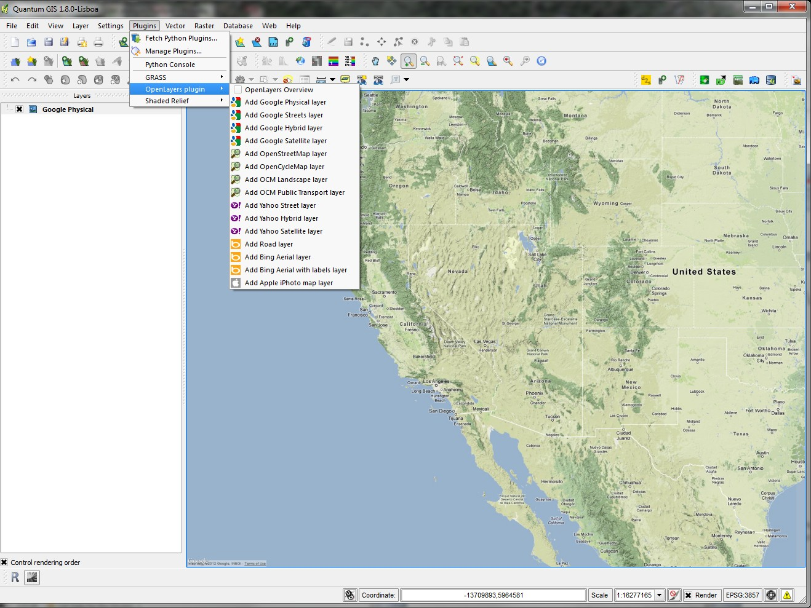
Try Google Physical or Bing Aerial for non-urban areas. These base maps are zoom-dependent and set at their respective web servers, so you will not be able to alter them directly.
- Once you add the basemap, the points we had previously added seemed to have disappeared. This is because the basemap layer is on top of the data points and QGIS draws in order of layers. Drag the point layers on top of the base map to see both layers at once.

- Adding a base map: vector layer
- Now we will also add polygon layers that are useful to our analysis. Use the Load Vector
to browse for shapefiles we have available for this workshop:

- World Wildlife Fund Terrestrial Ecoregions
- GADM- Global Administrative Areas- SouthAmerica_level0

- Spatial Query with Vectors
- Use the Plugin, Spatial Query, (Plugin->Spatial Query or install)
Allows selecting features in one layer in reference to another. The available operators depend on the selected target layer (point, line, polygon).
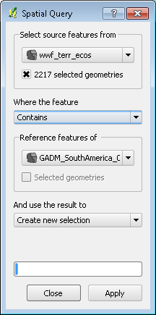
Operators for polygon on polygon include:
- Contains
- Equals
- Intersects
- Is Disjoint
- Overlaps
- Touches
- Within

After selections are applied, Click the menu Layer->Save Selection as Layer to save the selected polygons as a new shapefile.
Give it a name that allows you to trace easily its origins and new extent. (eg.”wwf_ecoregions_SouthAmerica” of you created a subset of ecoregions based on the GADM_SouthAmerica layer)

- Creating transect lines based on projected points
- Downloading the Points2One Plugin
  - We can download the Points2One Plugin in the same way we downloaded OpenLayers. To do this, click on “Plugins” at the top of the window, then select “Fetch Python Plugins”.
  - Under the tab “Plugins”, type “Points2One” into the box for “Filter:”
  - Select “Points2One” and click “Install Plugin”
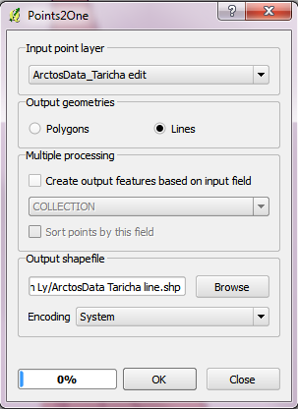
Using Points2One
  - Click on “Plugins” in the main menu and select Points2One
  - Select the data set you are working on under the pull-down menu for “Input Point Layer”. Since we are only using one data set, there should only be on option.
  - Under “Output geometries” select an option based upon how you want to represent your data. “Polygon” will produce a closed figure that encompasses your points. “Line” will draw a line that connects your data points.
  - The “Multiple processing” area allows you to add in another column from your data set that may be informative. You can also check the box below it to sort the order of your points based upon this extra field.
  - In order to create this new object, click on “Browse” in “Output shapefile” and name the new shapefile, then click “Save”.
  - At the bottom of the Points2One menu, click OK, then click “Yes” when prompted. The new feature class should appear on the screen.

- Creating a minimum bounding polygon
  - It’s pretty easy to create a minimum bounding polygon in QGIS. Just click on “Vector” in the menu, then scroll down to “Geoprocessing Tools” and select “Convex hull(s)”.
NOTE: Other Vector menu functions also in Geoprocessing Tools include: Buffer, Intersect, Union, Clip, Difference, Dissolve, which allow vector manipulation. Other useful functions are in the Data Management Tools: Split Vector, Merge layers. These are enabled from the fTools plugin that can be disabled or enabled from the Plugin Manager, and is automatically installed in version 1.7.
  - Select the feature you are working with, then select the option “Create single minimum convex hull”.
  - In order to create the object, click on “Browse” under “Output shapefile”. Name and save the file, as we’ve done before, then click “OK” at the bottom of the menu.
  - The minimum bounding polygon should appear overlaid on the map.
Using a minimum bounding polygon of species points, can you select points of another species which overlap in range? Of ecoregions?

- Finding the centroid
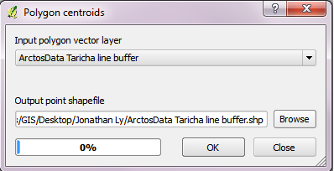
  - Click on “Vector” again, but this time, scroll down to “Geometry Tools” and select “Polygon centroids”.

  - Select the feature you are trying to find a centroid for under the pull-down menu.
  - Create the object in the same way we’ve done before, using the “Browse” button.
  - Click OK, and your centroid should appear within the polygon.

How far apart are the range centers of sister species pairs? Or sympatric species?

- Selections and creating subsets of your data
There are several ways to subset your vector data based on queries or spatial selections.
- Select by another vector layer
Click through Vector menu-> Research Tools->Select by location to bring up the following window, which allows selecting one vector layer based on its intersection with another. Warning: this selection method may take a while if one of your polygon layers is complicated or large.
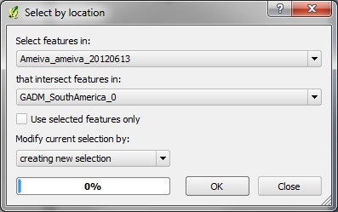

- Select by Attributes table
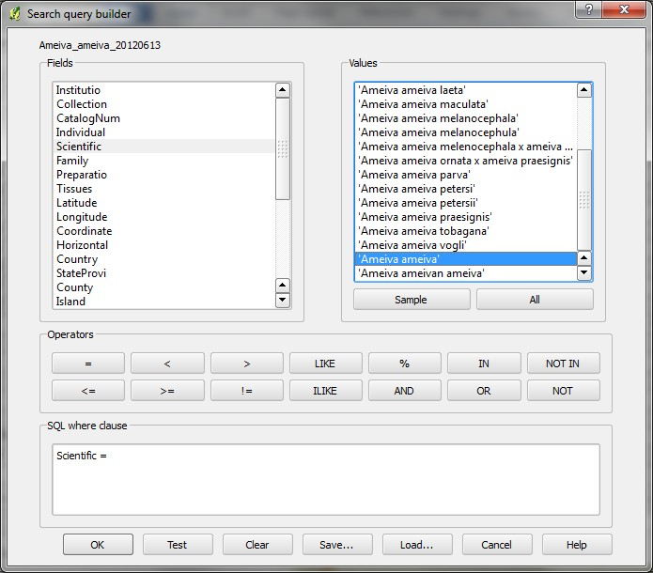
Right-click on the layer to subset, and open attribute table. Click on the Advanced button on the bottom to open the window below:

This allows very powerful SQL queries on the attributes to be made. To see the values in a given field, highlight on the left hand panel and click Sample on the right panel to display. Double-clicking will move the value to the conditions box at the bottom.
- Select through Spatial Query
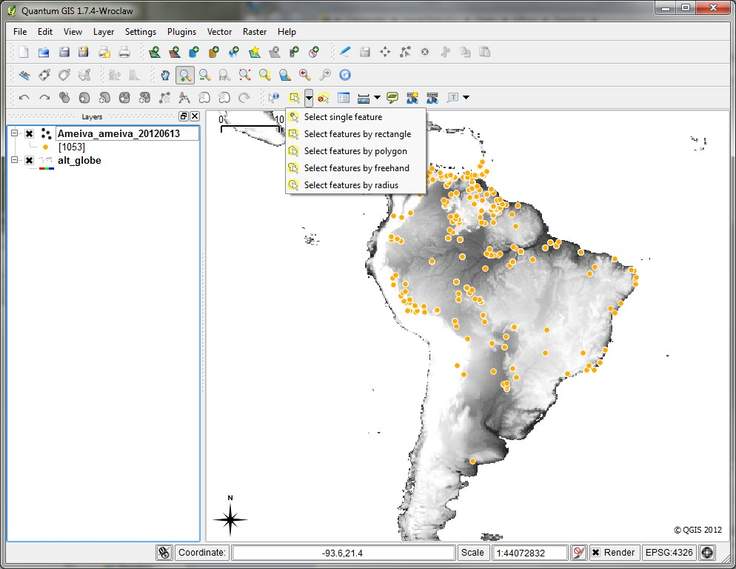
The simplest may be selecting features by drawing a box, circle or polygon
Selected features will highlight in yellow:
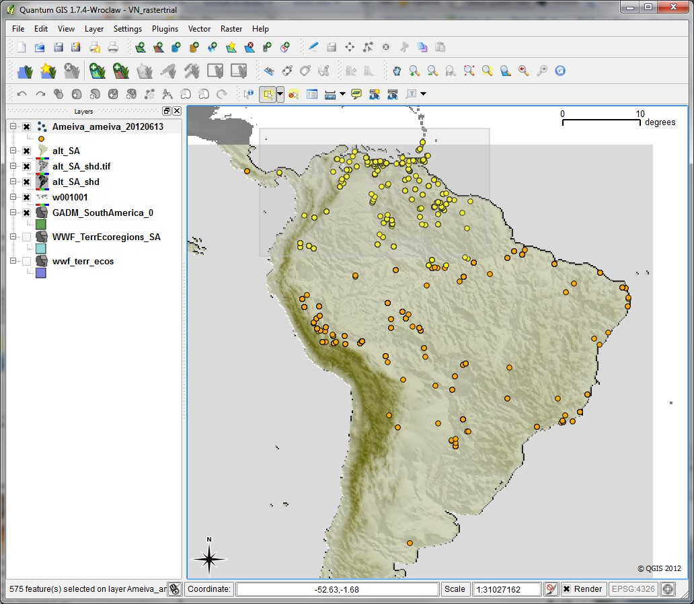

With any selection method, right-click on the layer and click Save Selection As, either as shapefile or CSV if you are formatting for Maxent.

NOTE: Selecting spatially is also a good way to delete outliers. Right-click to open the Attributes Table and with the outliers selected, use the bottom Delete Selection button or CNTRL+D. Also, remember that you can inverse your selection in the Attribute Tables since sometimes it’s easier to select what you are not interested in, then inverse the selection to have highlighted what you want.

- Formatting for Maxent
You can open your Saved selection in CSV in Excel, to delete columns leaving only Scientific Name, X(or Longitude), Y(or Latitude). Other useful applications maybe a text editor like the freeware Notepad++ (http://notepad-plus-plus.org/).
At the end of this section, you will need to have your original sample dataset ready for modeling. The format should look like the following: species_ID, Longitude, Latitude in CSV format (see below for an example). You may have other fields following these three core fields, but they will be ignored for the most part in the modeling algorithms we will be using.
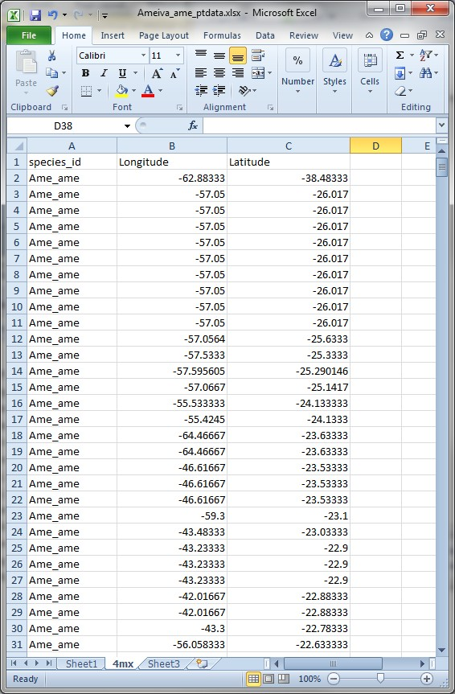

Updated 11 Oct 2012, MSK

