Georeferencing Guidelines as written for the Macrofungi Collection Consortium TCN
Submitted and written by: Shannon Asencio
Head, Collections Services and Information Management / Chef, Services des collections et gestion de l’information. Research and Collections / Recherche et Collections
Canadian Museum of Nature / Musée canadien de la nature

Original date written about 2013.
Software: GEOLocate, Symbiota

Point-radius Method Using GEOLocate

GEOLocate is a software program that was designed at Tulane University specifically for the purpose of georeferencing natural history collections. This excellent resource is embedded right into the MyCoPortal, so it is very easy for MaCC project participants to use. One important thing to note about GEOLocate is that it is not capable of georeferencing collection localities that are only to county level. For these collections, you will need to use the methods described in the previous section of this document.

GEOLocate and the MyCoPortal

In the MyCoPortal, you will see the GEOLocate symbol next to the Google Maps symbol:



With your complete locality data already filled in (i.e. the locality information from the collection label), simply click on the GEOLocate symbol.

Example: West of Valley Springs on Highway 12, Calaveras Co., CA

Click on the GEOLocate icon:

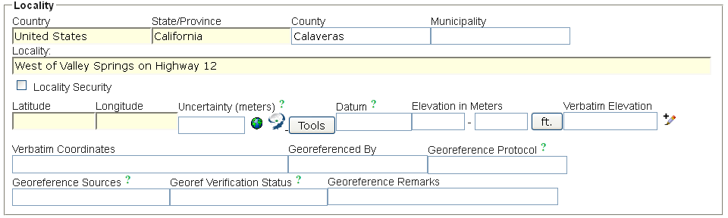

A pop-up window will appear and the map will look like this:
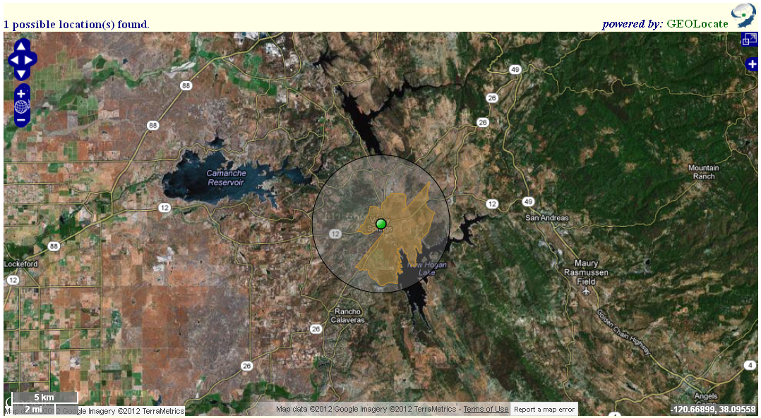
Uncertainty radius
Georeferenced point

As you can see, GEOLocate has plotted the georeferenced point to the populated center of Valley Springs. As such, the georeferenced point is inaccurate because the specimen was collected west of Valley Springs.

The next step is to zoom into the map. From there, determine the approximate midpoint of Highway 12 west of the westernmost limit of Valley Springs and where Highways 12 and 88 intersect. Click on the green dot and drag it to the midpoint of Highway 12 west of Valley Springs.
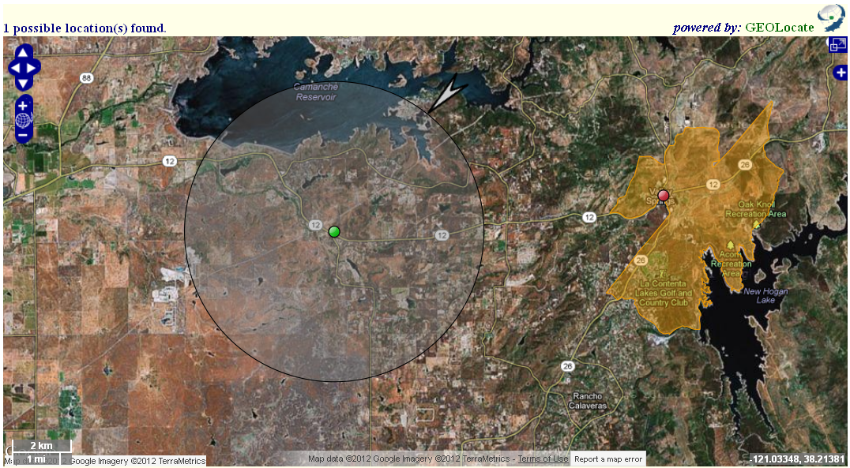

Since the collector didn’t specify exactly where the specimen was collected west of Valley Springs, the uncertainty must be expanded to cover the entire distance from the western limit of Valley Springs to the intersection of Highways 12 and 88. To edit the uncertainty, click on the green dot. When the following pop-up window appears, click “Edit uncertainty”:

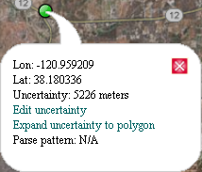

This action will make the following arrow appear at the upper-right side of the uncertainty radius:

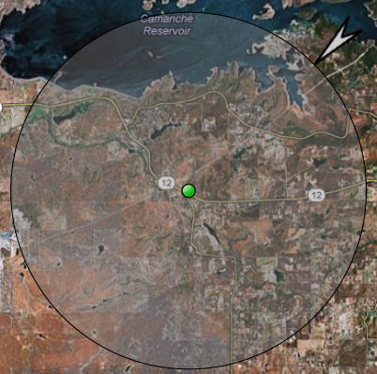

To adjust the uncertainty, click on this arrow and drag the uncertainty radius to cover the entire distance from the western limit of Valley Springs to the intersection of Highways 12 and 88. You can also adjust the placement of the green dot at this time to reduce the amount of uncertainty associated with the georeferenced point.

The resulting map with uncertainty covering the entire distance should look like this:
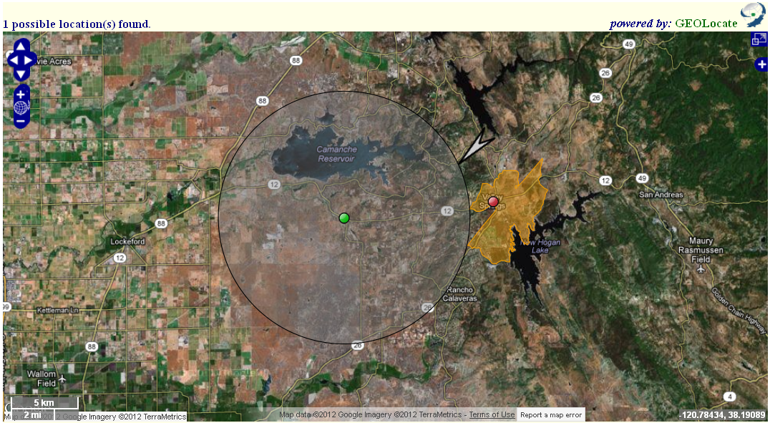
Intersection of Highways 12 & 88
Western limit of Valley Springs

Below the map, you will see several data fields that look like this:

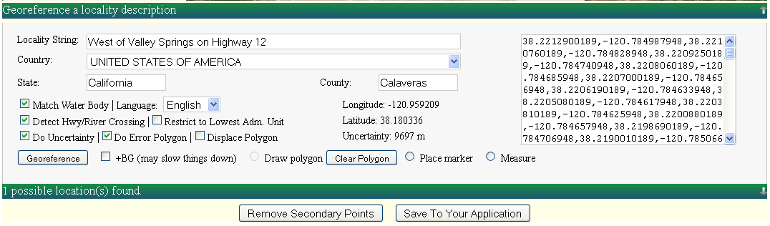

Click “Remove Secondary Points”, which will remove the red dot (i.e. the automatically generated georeferenced point). Then click “Save To Your Application”. The GEOLocate window will close automatically and several “Locality” fields in the MyCoPortal will be populated.
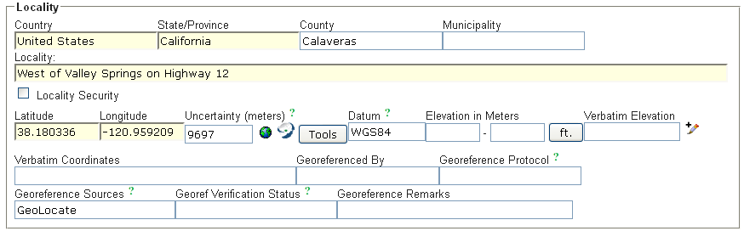
GEOLocate has automatically filled the “Latitude”, “Longitude”, “Uncertainty (meters)”, “Datum”, and “Georeference Sources” fields. Since GEOLocate uses Google Maps, the datum will always be WGS84.

- Country: United States
- State/Province: California
- County: Calaveras
- Latitude: 38.180336
- Longitude: -120.959209
- Uncertainty: 9697
- Datum: WGS84
- Georeference Sources: GEOLocate

Although GEOLocate has auto-filled some fields, there is still more work to be done. Before the MyCoPortal occurrence record is saved, the fields should look like this:

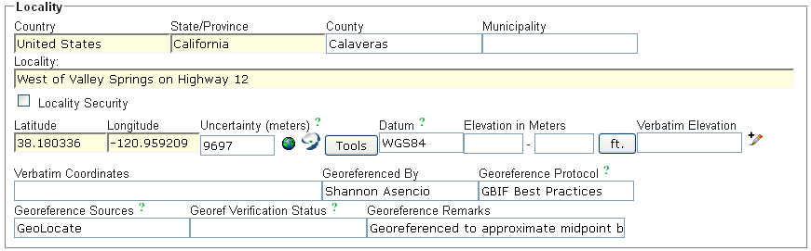

- Country: United States
- State/Province: California
- County: Calaveras
- Latitude: 38.180336
- Longitude: -120.959209
- Uncertainty: 9697
- Datum: WGS84
- Georeferenced by: Shannon Asencio. The georeferencer’s name is entered into this field.
- Georeference Protocol: GBIF Best Practices. Always enter this information into the “Georeference Protocol” field.
- Georeference Sources: GEOLocate
- Georef Verification Status: reviewed – high confidence. If the georeferencer is an experienced user, and they should be, this comment will always be entered into the “Georef Verification Status” field.
- Georeference Remarks: Georeferenced to approximate midpoint between western limit of Valley Springs and intersection of Highways 12 and 88. This is a complete remark that clearly demonstrates how the georeferencing decision was reached.

Some final notes about Google Maps and GEOLocate

Map Views

Everybody will have their own preference with regards to which map view they prefer. In both Google Maps and GEOLocate, the map view is easily adjusted.

To adjust your map view in Google Maps from standard map (default) to satellite, simply click on the “Satellite” box in the upper-right portion of the map.

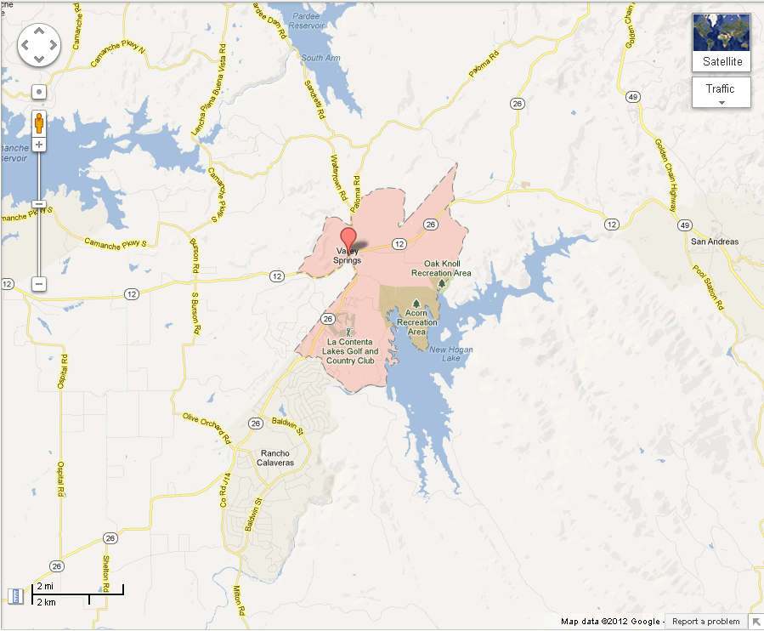

Satellite map

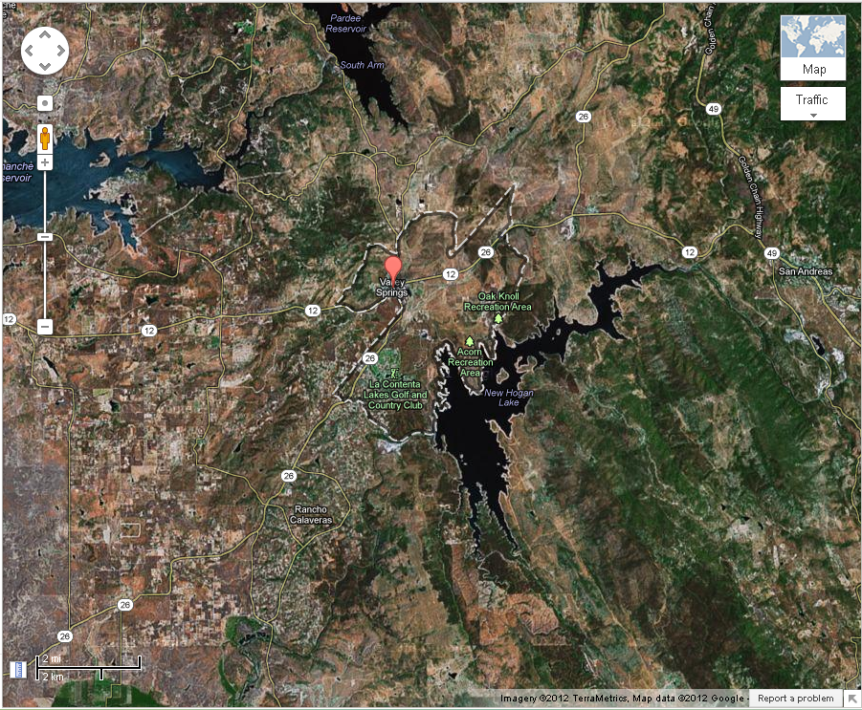
While in standard map view, you may view the terrain of the map. This is particularly useful when the elevation is included in the description of a collection site (e.g. Mount Rainier, WA, 2315 m). To view the terrain map, simply hover your mouse over the “Satellite” box and a drop down list will appear. Select “Terrain”.

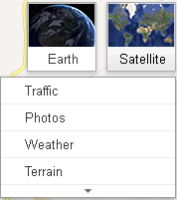

Terrain map

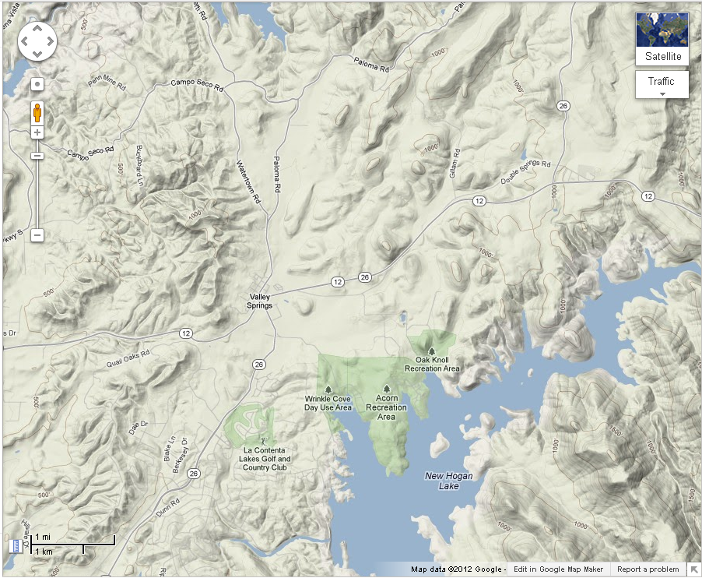

In GEOLocate, the map view can be changed by clicking on the white plus symbol in the upper-right portion of the screen.



Clicking on this button will show the following drop-down list:

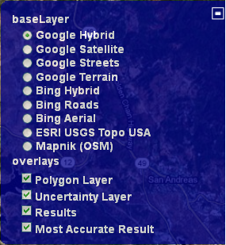

In GEOLocate, working in full screen mode makes working with the map much easier. To view the map in full screen, simply click on the icon in the upper-right portion of the screen.

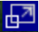

GEOLocate Uncertainty Radius

Sometimes the plotted point will be off-center, but the user will want to keep the point in that location. An example of such a situation is the previously discussed georeferencing of a locality’s populated center, rather than the locality’s geographic center. This is important because sometimes the populated center of a city, for example, is not in the geographic center of the city. For the following example, we will use Kalispell, MT.

After entering the country (i.e. United States), state (i.e. Montana), county (i.e. Flathead), and locality (i.e. Kalispell), and clicking on the GEOLocate button in the MyCoPortal, the following map pops up:
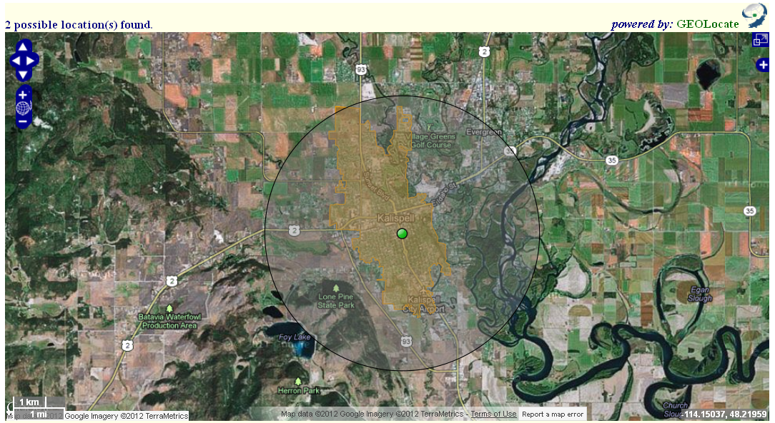
Polygon extending beyond uncertainty radius

As you can see, the green dot has not been plotted in the exact geographic center of Kalispell. The gazetteer has placed this point here because it represents the populated center of the city. The uncertainty radius does not fully extend to all sides of the polygon that represent the city limits. In order to change the radius to accurately represent the extent of the city limits, click on the green dot. When the pop-up window appears, click on “Expand uncertainty to polygon”.

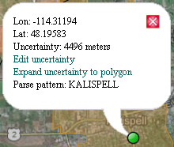

This action will expand the uncertainty radius to just include all edges of the polygon.
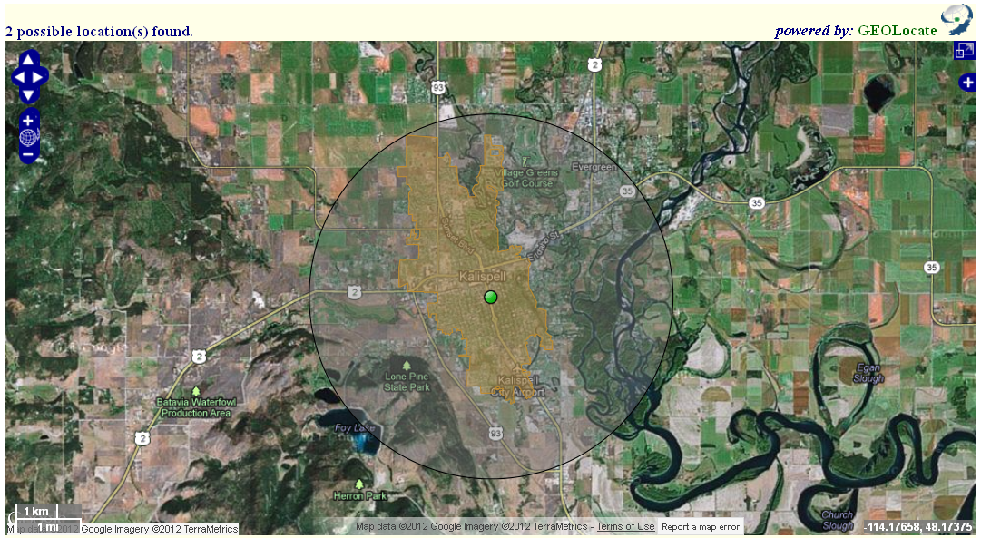

At present, there is no feature in GEOLocate that shrinks the uncertainty radius to just fit all edges of the polygon. This will need to be done manually by clicking “Edit uncertainty” and dragging the arrow to adjust the radius. The GEOLocate team is working on implementing this feature and it should be ready for use soon, so keep your eye out for this new and useful function.

