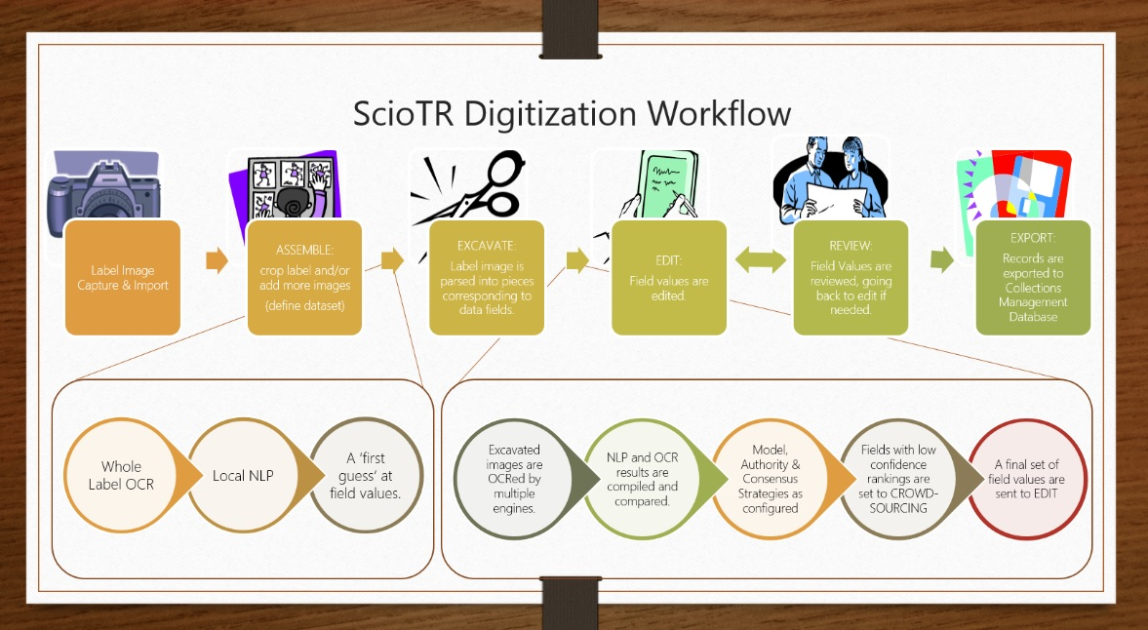
The ScioTR Digitization Workflow integrates a number of different technologies in the following order:
- ASSEMBLE: A user groups or crops images into sets that correspond to an occurrence/specimen record.
- Whole-Label OCR/NLP: Before a user has begun to break the label data into fields, a local or remote OCR/NLP is run on the entire label, potentially pulling out specific fields.
- EXCAVATE: In this context, ‘Excavation’ is the parsing of the image of a label into smaller images that correspond to specific fields in a database or data model. In ScioTR, this is accomplished by moving the corners of a box (cropping) around a region of a label, either by touch screen gesture or mouse dragging and a click or tap on the corresponding name of the field in a configurable list.
- At this point, if step 1 (whole-label OCR /NLP) has furnished an appropriate value for the field, the user may choose not to excavate that field. As each excavated image is created, it is sent immediately to at least one OCR engine.
- A Consensus Strategy compares whole-label OCR/NLP and multiple excavated image OCR results are compared to provide a suggestion for each field, if configured.
- A Machine Learning Strategy compares current excavated image OCR results with previous values and their corresponding corrected values and provides suggestions, if configured. This is extremely useful in the case of small symbols (male, female, spore drawings) or other non-text handwritten things that occur on labels. Potentially, it could be powerful enough to detect small pieces of handwriting that are seen multiple times.
- An Authority Strategy checks excavated image OCR results with authority lists (perhaps from the existing collection database) for the same field and provides suggestions, if configured. This is particularly useful in situations where checking for a pre-existing ‘duplicate’ record exists in an existing system of record (collections database or data aggregator), or checking for taxon synonym names, etc.
- A Crowdsourcing website picks up excavated images/data fields with low confidence rankings, if configured.
- EDIT: Values from each of the engines are shown with excavated images in the Edit screen. The user may choose one engine value and/or edit as needed.
- REVIEW: Final values for each field are shown in the order they were excavated from the original image next to the original image for a final data check.
- EXPORT: Data can be exported from ScioTR as a CSV file or can be imported with the excavated images directly to ScioQualis.com (Cloud-based Collections Management Tool).
For a video demo, please see:
ScioTR Progress Video, 26 June 2013 http://youtu.be/mkE4Af5840Q
Check the ScioTR Website for current status updates on this project as well as the PPT of a talk given at SPNHC 2013 on this tool. www.ScioTR.com

